

 



ICT Banking TEAM( A )

Contents

Physical Topology 3

IP Planning for YGN 4

IP Planning for Mandalay Branch 5

IP Planning for Nay Pyi Taw Branch 6

Configuration for Yangon 7

CSW Configuration 7

ASW Configuration 9

DHCP Server 10

IGW 10

OSPF 11

Verification 12

Upload Virtual Machine and IP addresses 13

DNS Record 19

ISCSI Shared-storage 20

Load Balancer with KEMP 22

Uploading Two Websites 24

High Avaliability ( HA ) 27

Backup with Veritas 28

## 

## Physical Topology

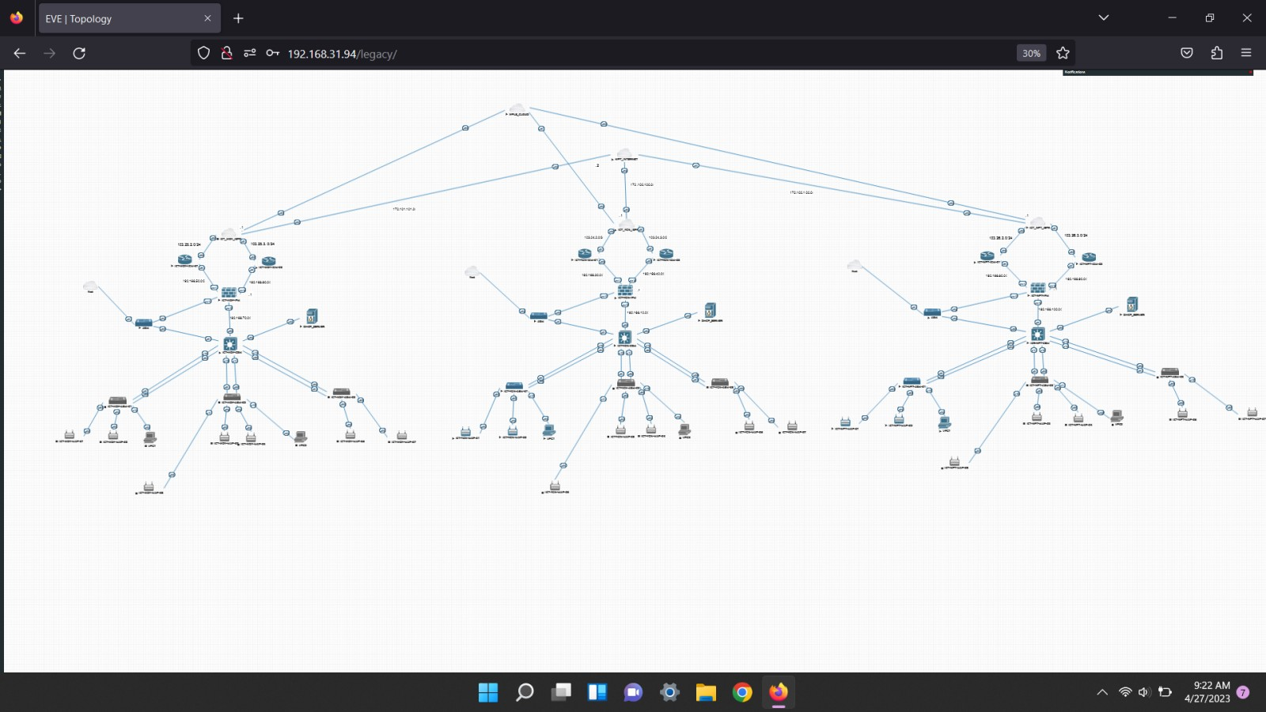

## IP Planning for YGN

|  |  |  |  |
| --- | --- | --- | --- |
| Devices | INTERFACE | IP | |
| ISP-Router | * e0/0 * e0/1 * e0/2 | | 103.24.2.1/30  103.24.3.1/30  172.100.100.1/24 |
| ICT-YGN-IGW-01 | * e0/1 * e0/2 | | 103.24.2.2/30  192.168.30.2/24 |
| ICT-YGN-IGW-02 | * e0/1 * e0/2 | | 103.24.3.2/30  192.168.40.2/24 |
| ICT-YGN-CSW | * e0/0 * VLAN 10 * VLAN 100 * VLAN 200 * VLAN 300 * VLAN 400 * VLAN 600 * VLAN 700 * VLAN 900 * VLAN 1000 | | 192.168.10.2/24  10.0.10.1/24  10.0.30.1/24  10.0.40.1/24  10.0.50.1/24  10.0.60.1/24  10.0.255.25/24  10.0.255.26/24  10.0.255.36/24  10.0.255.38/24 |
| ICT-YGN-FGW | * Port 1 * Port 2 * Port 3 * Port 4 | | 192.168.30.1/24  192.168.40.1/24  192.168.10.1/24  192.168.31.87/24 |
| DHCP Server | * e0/0 | | 10.0.10.10/24 |

|  |  |
| --- | --- |
| Devices | IP |
| VPC1 | DHCP Method |
| VPC2 | DHCP Method |
| ICT-YGN-WAP-01 | DHCP Method |
| ICT-YGN-WAP-02 | DHCP Method |
| ICT-YGN-WAP-03 | DHCP Method |
| ICT-YGN-WAP-04 | DHCP Method |
| ICT-YGN-WAP-05 | DHCP Method |
| ICT-YGN-WAP-06 | DHCP Method |
| ICT-YGN-WAP-07 | DHCP Method |

## IP Planning for Mandalay Branch

|  |  |  |  |
| --- | --- | --- | --- |
| Devices | INTERFACE | IP | |
| ISP-Router | * e0/0 * e0/1 * e0/2 | | 103.25.2.1/24  103.25.3.1/24  172.101.101.1/24 |
| ICT-MDY-IGW-01 | * e0/0 * e0/1 | | 103.25.2.2/30  192.168.50.2/24 |
| ICT- MDY -IGW-02 | * e0/0 * e0/1 | | 103.25.3.2/30  192.168.60.2/24 |
| ICT- MDY -CSW | * e0/0 * VLAN 10 * VLAN 100 * VLAN 200 * VLAN 300 * VLAN 400 | | 192.168.70.2/24  10.1.10.1/24  10.1.30.1/24  10.1.40.1/24  10.1.50.1/24  10.1.60.1/24 |
| ICT- MDY -FGW | * Port 1 * Port 2 * Port 3 * Port 4 | | 192.168.50.1/24  192.168.60.1/24  192.168.70.1/24  192.168.31.84/24 |
| DHCP Server | * e0/0 | | 10.1.10.10/24 |

|  |  |
| --- | --- |
| Devices | IP |
| VPC1 | DHCP Method |
| VPC2 | DHCP Method |
| ICT- MDY -WAP-01 | DHCP Method |
| ICT- MDY -WAP-02 | DHCP Method |
| ICT- MDY -WAP-03 | DHCP Method |
| ICT- MDY -WAP-04 | DHCP Method |
| ICT- MDY -WAP-05 | DHCP Method |
| ICT- MDY -WAP-06 | DHCP Method |
| ICT- MDY -WAP-07 | DHCP Method |

## IP Planning for Nay Pyi Taw Branch

|  |  |  |  |
| --- | --- | --- | --- |
| Devices | INTERFACE | IP | |
| ISP-Router | * e0/0 * e0/1 * e0/2 | | 103.26.2.1/24  103.26.3.1/24  172.102.102.1/24 |
| ICT-NPT-IGW-01 | * e0/0 * e0/1 | | 103.26.2.2/30  192.168.80.2/24 |
| ICT- NPT -IGW-02 | * e0/0 * e0/1 | | 103.26.3.2/30  192.168.90.2/24 |
| ICT- NPT -CSW | * e0/0 * VLAN 10 * VLAN 100 * VLAN 200 * VLAN 300 * VLAN 400 | | 192.168.100.2/24  10.2.10.1/24  10.2.30.1/24  10.2.40.1/24  10.2.50.1/24  10.2.60.1/24 |
| ICT- NPT -FGW | * Port 1 * Port 2 * Port 3 * Port 4 | | 192.168.80.1/24  192.168.90.1/24  192.168.100.1/24  192.168.31.83/24 |
| DHCP Server | * e0/0 | | 10.2.10.10/24 |

|  |  |
| --- | --- |
| Devices | IP |
| VPC1 | DHCP Method |
| VPC2 | DHCP Method |
| ICT- NPT -WAP-01 | DHCP Method |
| ICT- NPT -WAP-02 | DHCP Method |
| ICT- NPT -WAP-03 | DHCP Method |
| ICT- NPT -WAP-04 | DHCP Method |
| ICT- NPT -WAP-05 | DHCP Method |
| ICT- NPT -WAP-06 | DHCP Method |
| ICT- NPT -WAP-07 | DHCP Method |

## Configuration for Yangon

## CSW Configuration

In this Core Switch, we create VLAN 10,100,200,300,400 and give IP as above table. Then we give hostname **CSW**. Additionally, we do **EtherChannel**.

|  |  |
| --- | --- |
| Int | Configuration |
| Vlan10 | * interface Vlan10 * ip address 10.0.10.1 255.255.255.0 * ip helper-address 10.0.10.10 |
| Vlan100 | * interface Vlan100 * ip address 10.0.30.1 255.255.255.0 * ip helper-address 10.0.10.10 |
| Vlan200 | * interface Vlan200 * ip address 10.0.40.1 255.255.255.0 * ip helper-address 10.0.10.10 |
| Vlan300 | * interface Vlan300 * ip address 10.0.50.1 255.255.255.0 * ip helper-address 10.0.10.10 |
| Vlan400 | * interface Vlan400 * ip address 10.0.60.1 255.255.255.0 * ip helper-address 10.0.10.10 |
| e1/0 | * interface Ethernet1/0 * switchport trunk encapsulation dot1q * switchport mode trunk * duplex auto * channel-group 1 mode active |
| e0/3 | * interface Ethernet0/3 * switchport trunk encapsulation dot1q * switchport mode trunk * duplex auto * channel-group 1 mode active |
| e1/1 | * interface Ethernet1/1 * switchport trunk encapsulation dot1q * switchport mode trunk * duplex auto * channel-group 2 mode active |
| e1/2 | * interface Ethernet1/2 * switchport trunk encapsulation dot1q * switchport mode trunk * duplex auto * channel-group 2 mode active |
| e1/3 | * interface Ethernet1/3 * switchport trunk encapsulation dot1q * switchport mode trunk * duplex auto * channel-group 3 mode passive |
| e2/0 | * interface Ethernet2/0 * switchport trunk encapsulation dot1q * switchport mode trunk * duplex auto * channel-group 3 mode passive |
| e0/2 | * interface Ethernet0/2 * switchport access vlan 10 * switchport mode access * duplex auto |
|  |  |

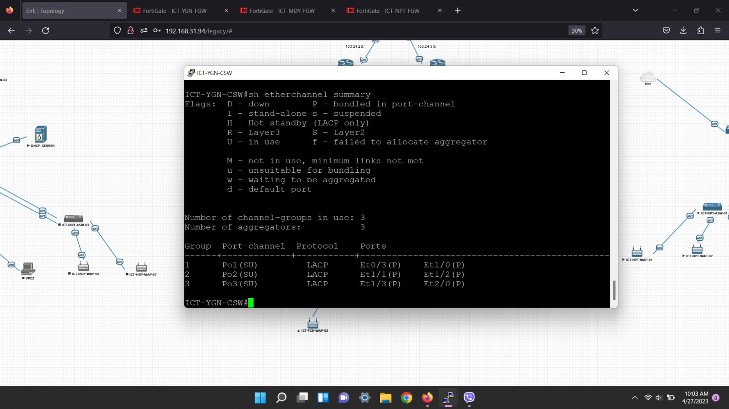

## ASW Configuration

In this Access Switch, we give IP as above table and hostname in each of **ASW1, ASW2 and ASW3.** And we do trunk and access for each VLANs and interfaces.

|  |  |
| --- | --- |
| INT | Configuration |
| e0/1 | * interface Ethernet0/1 * switchport trunk encapsulation dot1q * switchport mode trunk * duplex auto * channel-group 1 mode active |
| e0/0 | * interface Ethernet0/0 * switchport trunk encapsulation dot1q * switchport mode trunk * duplex auto * channel-group 1 mode active |
| e0/2 | * interface Ethernet0/2 * switchport access vlan 300 * switchport mode access * duplex auto |
| e1/0 | * interface Ethernet1/0 * switchport access vlan 300 * switchport mode access * duplex auto |

## DHCP Server

Give help address for each VLANs in local interface. And we exclude some IP address that we already decided to exclude. Then, we create DHCP pool and do DHCP option(1,3,6).

**\*Option 1** = Subnet

**Option 2** = Gateway

**Option 6** = DNS Server*

|  |  |
| --- | --- |
| INT | Configuration |
| e0/0 | * interface Ethernet0/0 * ip address 10.0.10.10 255.255.255.0 |

## IGW

In each router, we do NAT inside and outside.

|  |  |
| --- | --- |
| INT | Configuration |
| e0/1 | * interface Ethernet0/1 * description "WAN" * ip address 103.24.2.2 255.255.255.252 * ip nat outside * ip virtual-reassembly in |
| e0/2 | * interface Ethernet0/2 * description "LAN" * ip address 192.168.30.2 255.255.255.0 * ip nat inside * ip virtual-reassembly in |

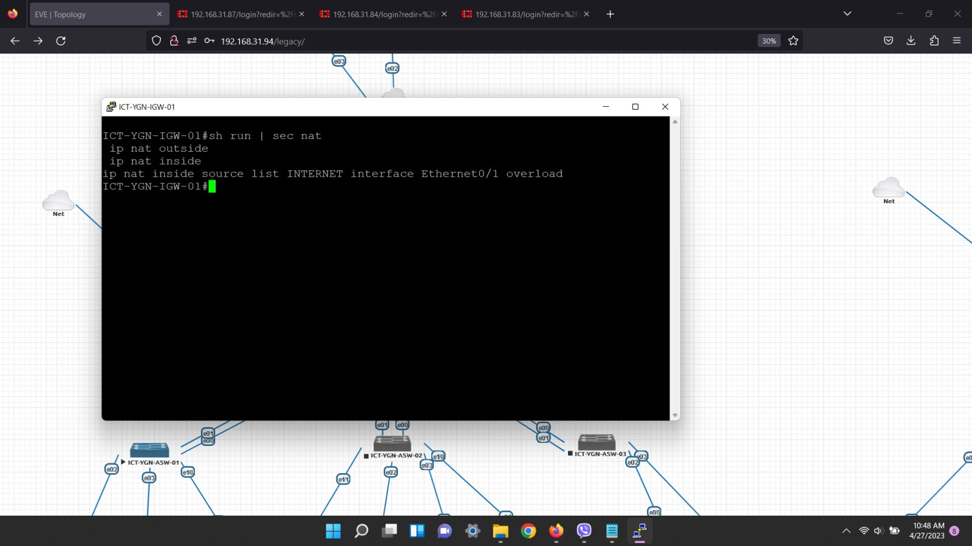

## OSPF

And we do OSPF process in each ISP router.

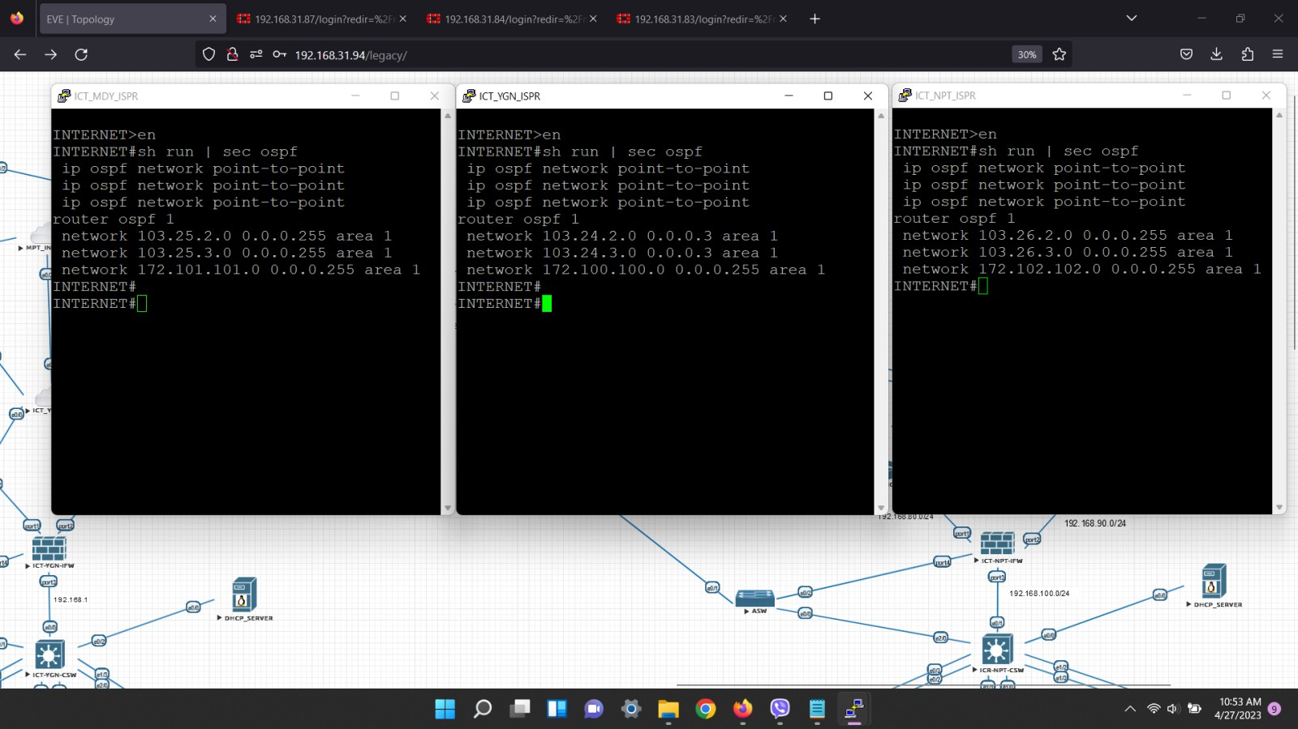

We can check its result by typing below command.

**( config )# do show run | sec ospf**

## Verification

In this figure we can see that we can ping from NPT PC1 to Lootback.

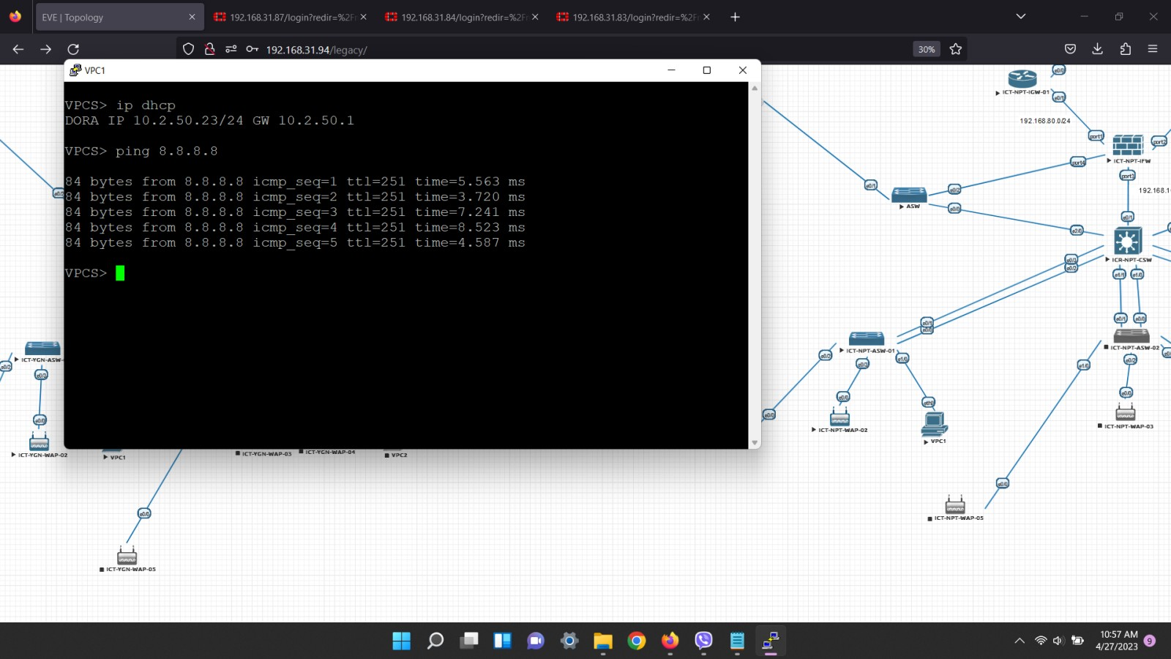

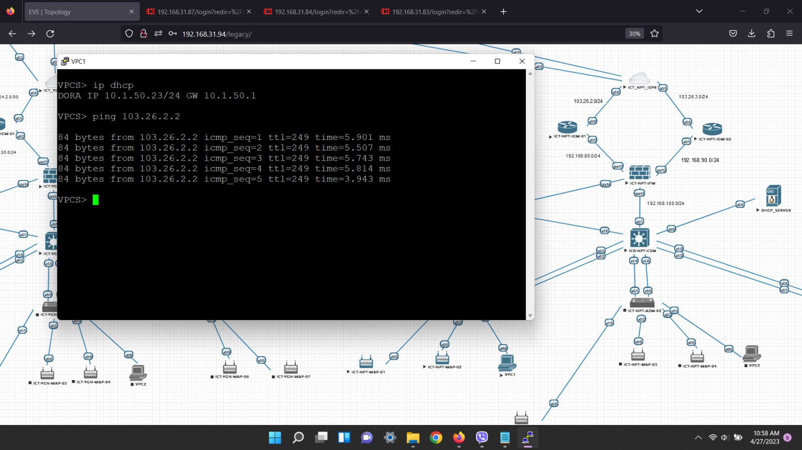

## Upload Virtual Machine and IP addresses

First 4 ESXI with the hostname of ICT-ESXI-01, ICT-ESXI-02, ICT-ESXI-03, ICT-ESXI-04 are deployed on server( 10.0.255.6). After being deployed, IP and DNS are configured as below.

|  |  |  |  |  |
| --- | --- | --- | --- | --- |
| **Host Name** | **IP&Subnet** | **DNS Server** | **Gateway** | **Version** |
| **ICT-ESXI-01** | **10.0.255.25/24** | **10.0.255.29** | **10.0.255.254** | **7.03** |
| **ICT-ESXI-02** | **10.0.255.26/24** | **10.0.255.29** | **10.0.255.254** | **7.03** |
| **ICT-ESXI-03** | **10.0.255.27/24** | **10.0.255.29** | **10.0.255.254** | **7.03** |
| **ICT-ESXI-04** | **10.0.255.28/24** | **10.0.255.29** | **10.0.255.254** | **7.03** |

**ICT-ESXI-01**

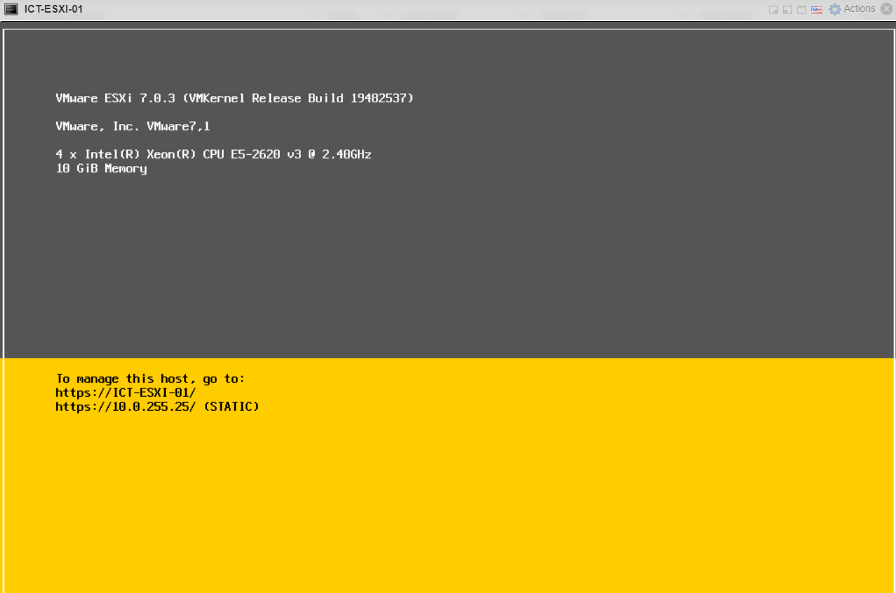

**ICT-ESXI-02**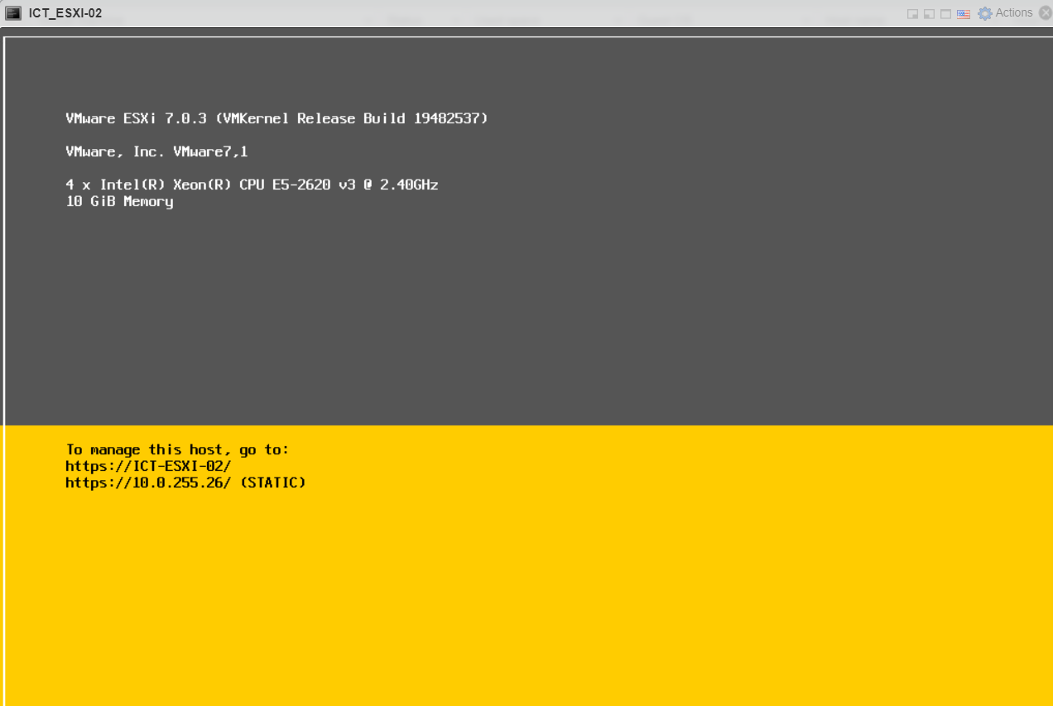

**ICT-ESXI-03**

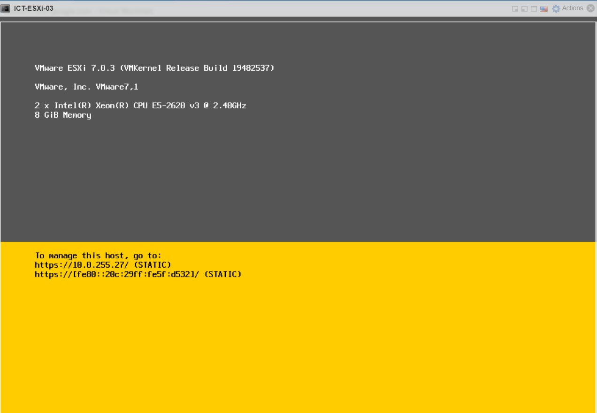

**ICT-ESXI-04**

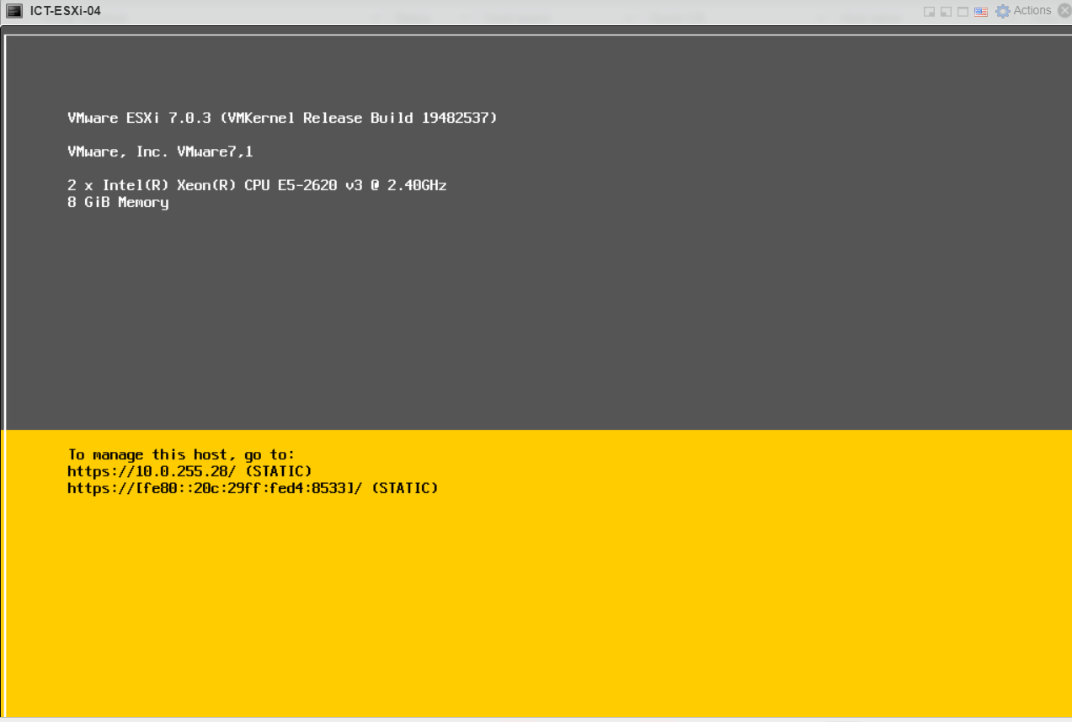

VCenter is built after that with the IP of 10.0..255.30 and added ICT cluster in data center and also add 4 ESXI hosts in that cluster as shown below.

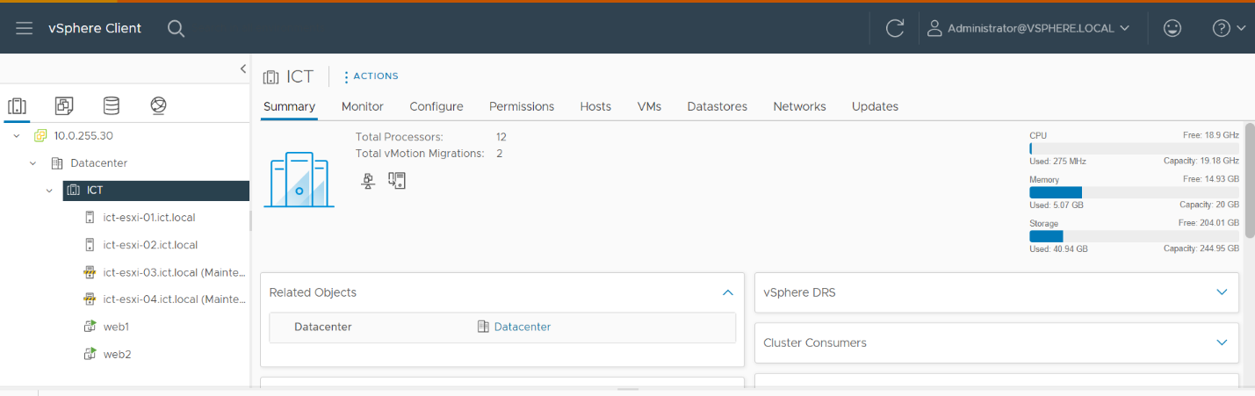

After that DNS Server is created with Microsoft Window Server 2012 and write A Record after installing DNS tools and giving appropriate IP addresses for DNS Server.

DNS Server IP and DNS server addresses

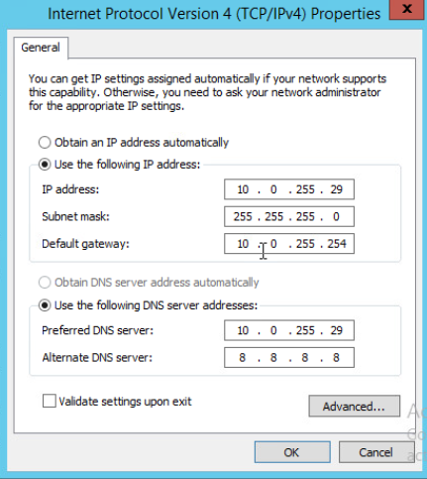

## DNS Record

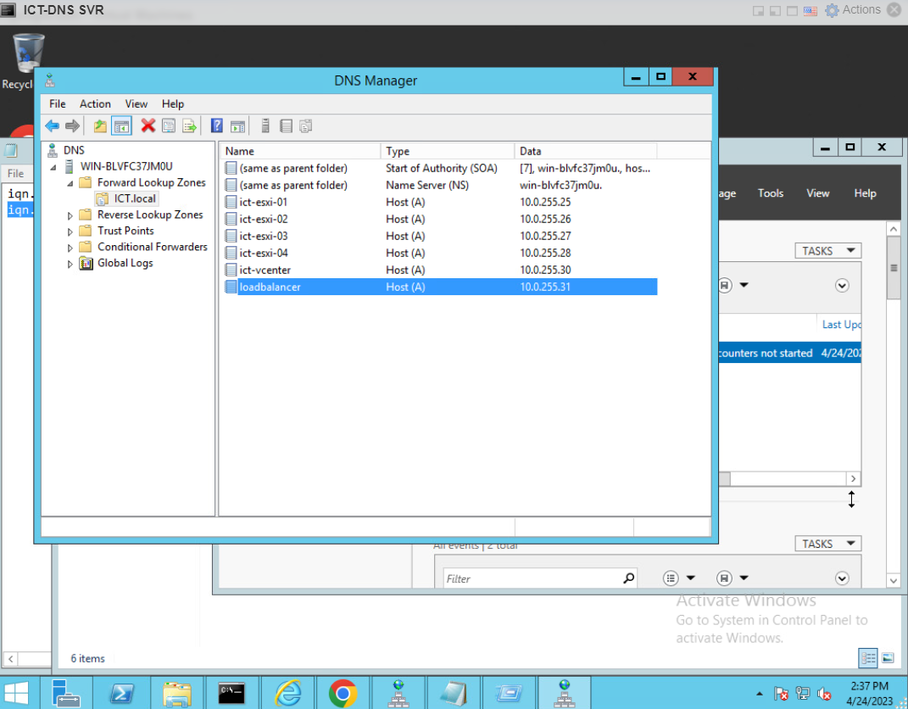

## ISCSI Shared-storage

After that we can start calling ESXI by name written in A record which is shown in above.

And we start installing ISCSI in ICT-str-server and after that we target ICT-ESXI-01 and ICT-ESXI-02.

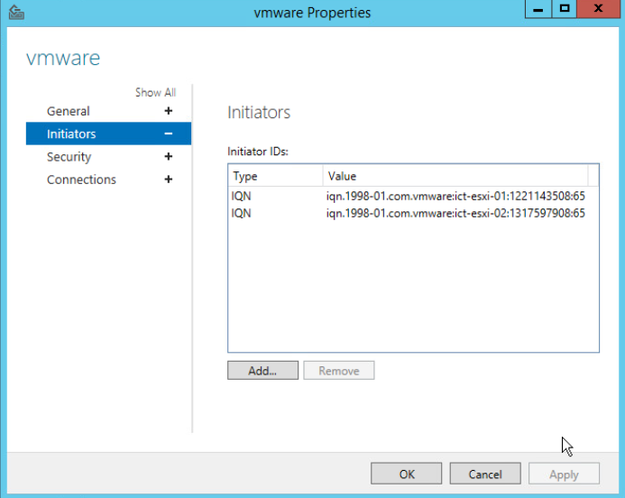

After being targeted, dynamic IP which is dns server IP must be added in both ESXI-01 and ESXI-02 software adapter.

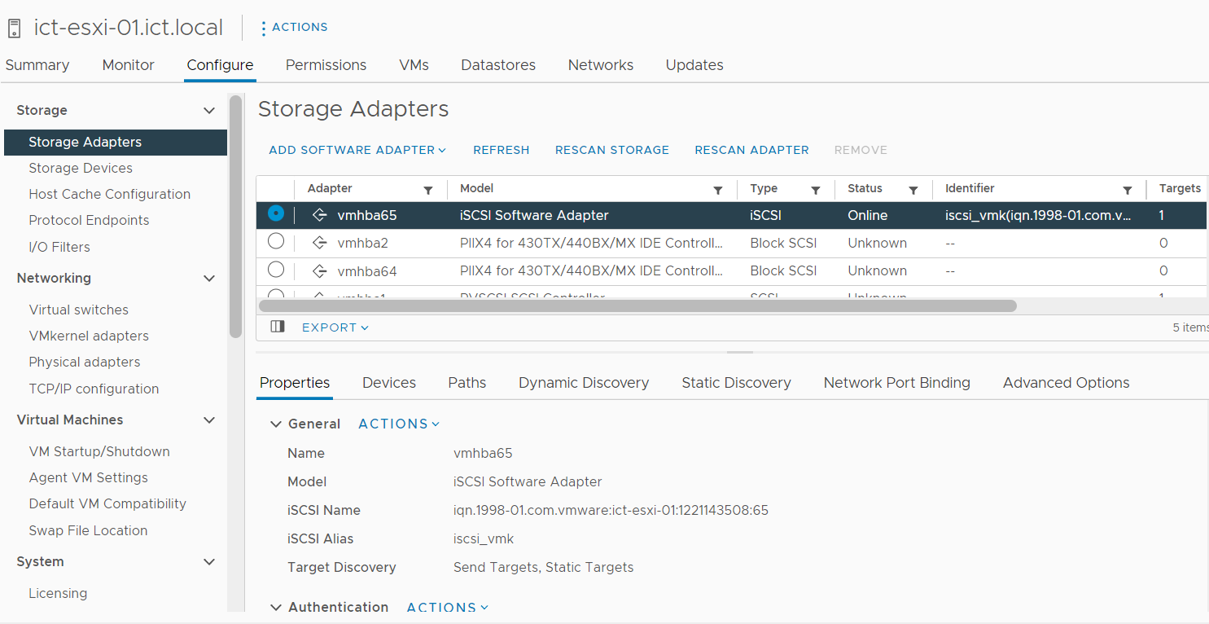

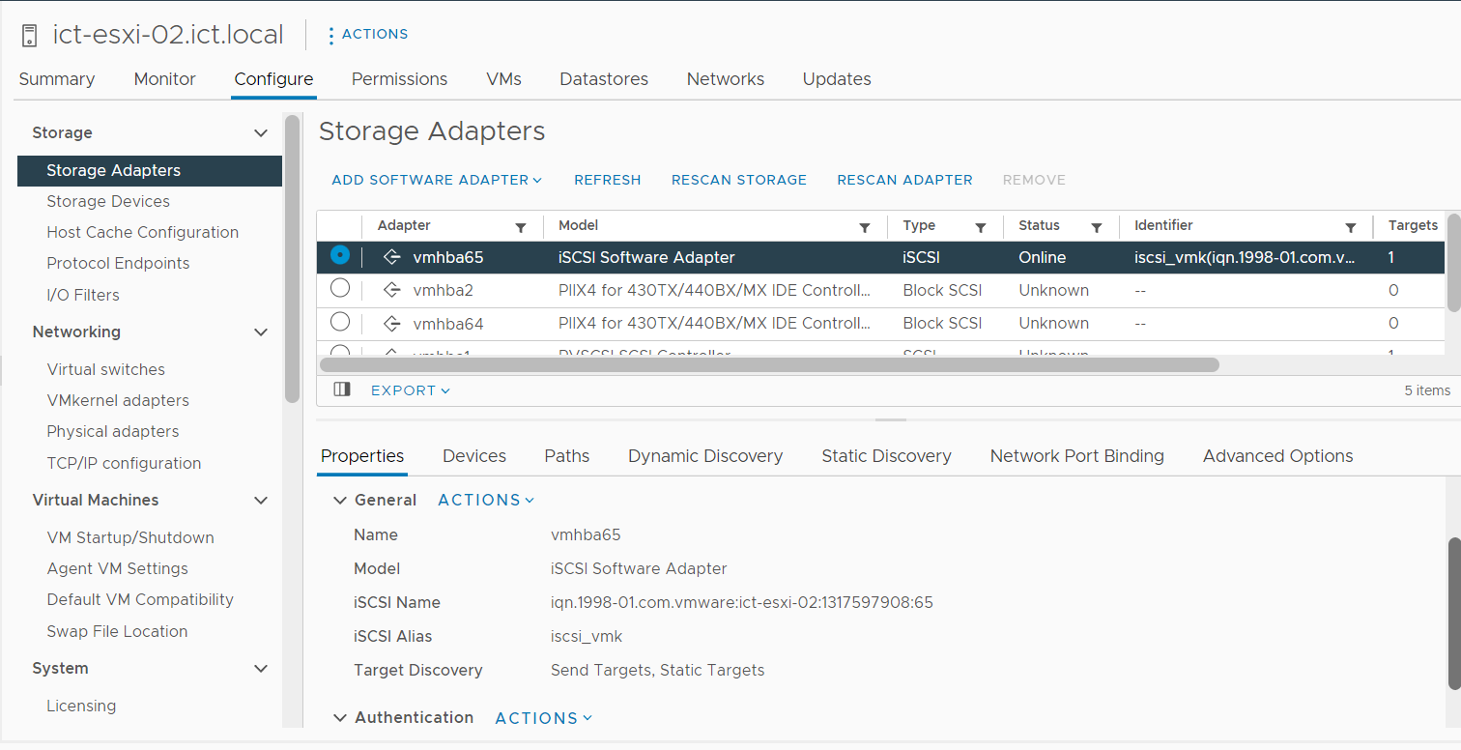

After that rescan storage in both ESXI-01 and ESXI-02 via VCenter and refresh VCenter to get result of shared storage in Storage Devices.

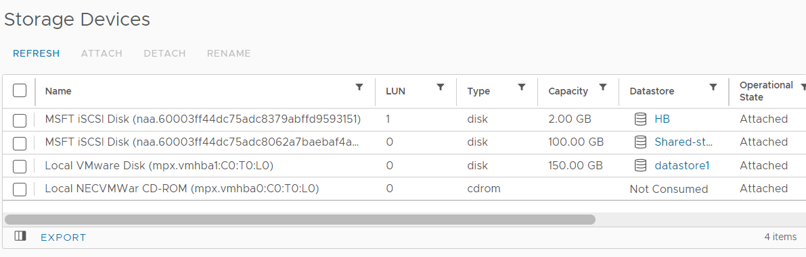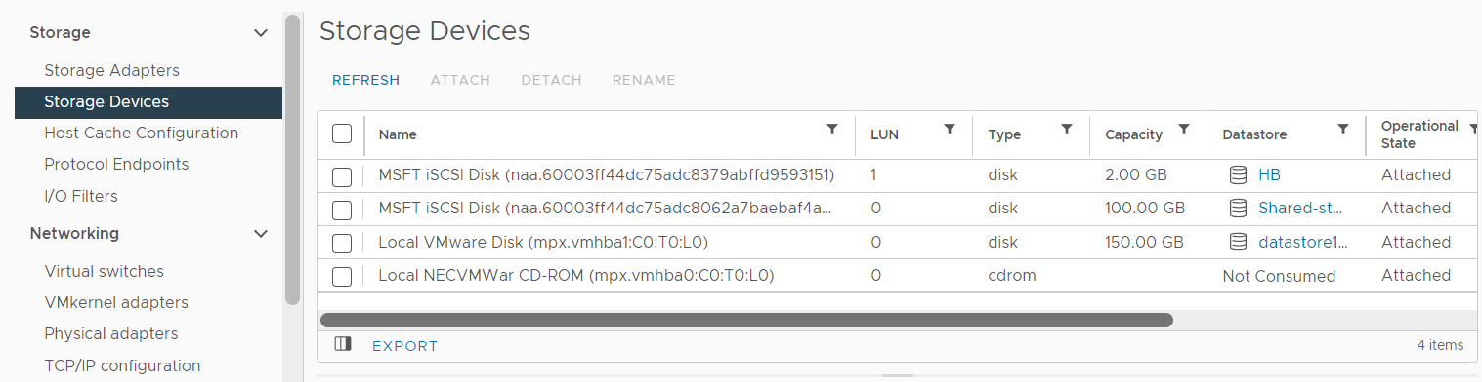

## Load Balancer with KEMP

As the same method as above, HB ISCSI data store must be built for redundancy purposes. For Final result, as we can see above, there must be three data stores each ESXI in total. One for shared storage, one for backup and one for own data store.

After having all these datastores, Web 1 and Web 2 which are deployed in ESXI-01( datastore-1 ) and ESXI-02 ( datastore-2) are migrated to shared-storage for future HA purpose.

Free Load Balancer is downloaded and deployed in 10.0.255.31.

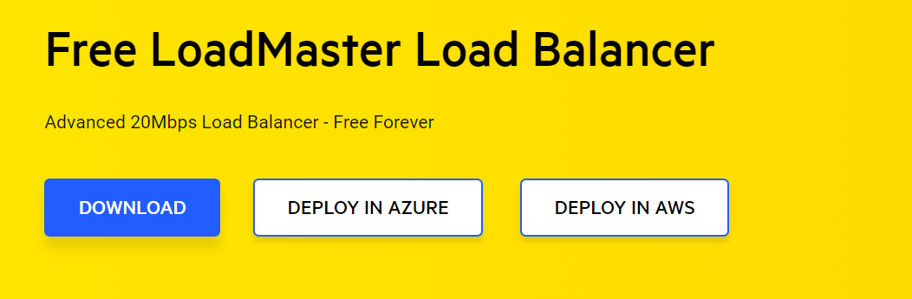

Load Balancer is installed and 10.0.255.31 is added as IP of load balancer and bind with DNS Server.

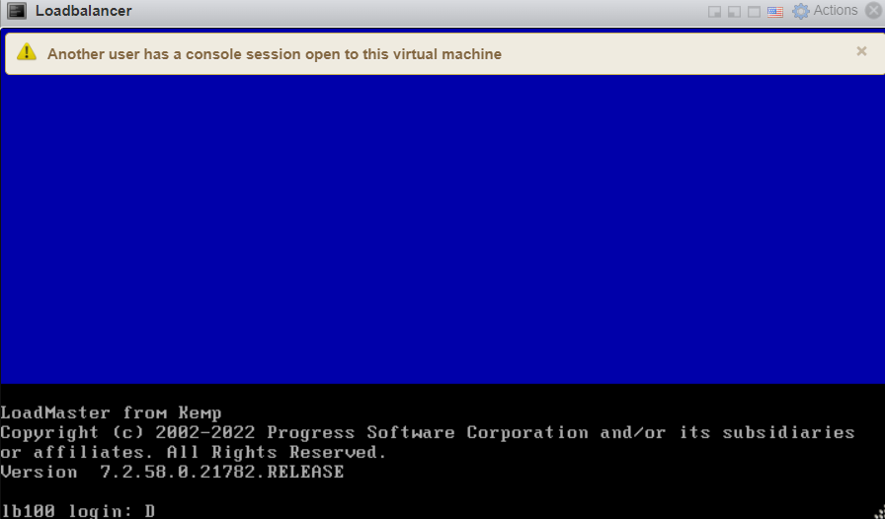

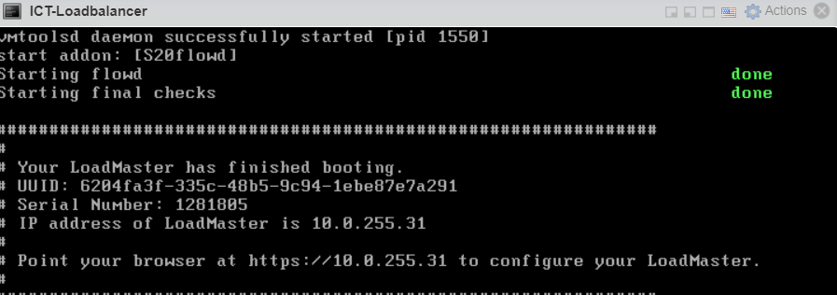

Both ESXI-01 and ESXI-02 are added in real servers of 10.0.255.169 as shown below for load balancing purposes.

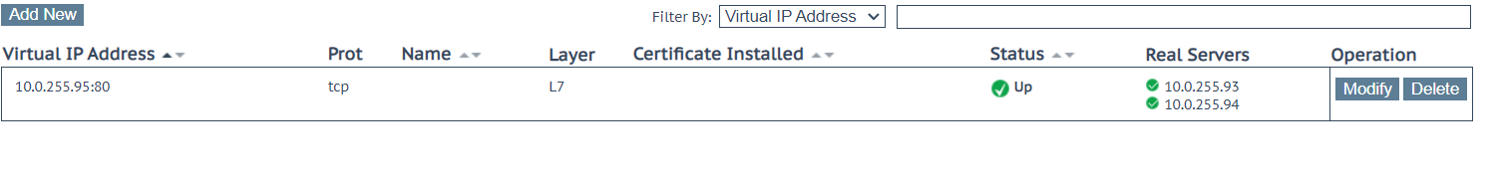

## Uploading Two Websites

Install two Ubuntu Web Servers and VMWare Tools. Inside command line, apache 2 is installed and used that as a web server which is later created as Web 1 and Web 2 which are installed in ESXI-01 and ESXI-02.



Since Two Websites are added on two ESXI, we can maintain them via VCenter as below.

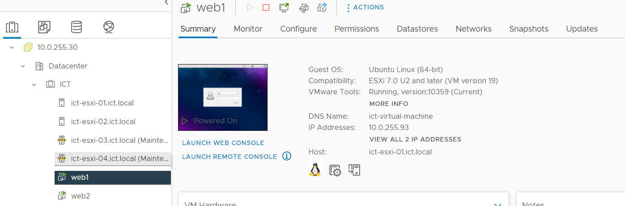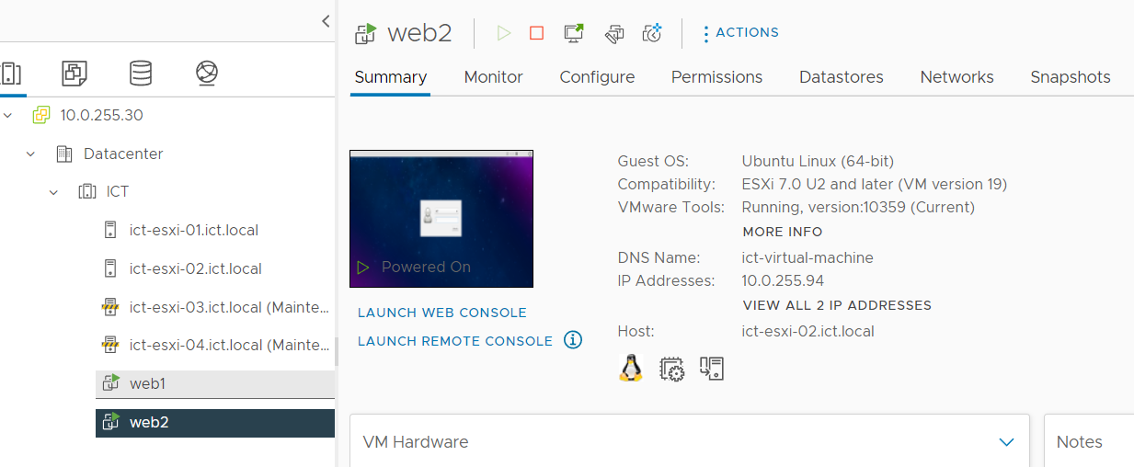

After that, we enable Vsphere HA and DRS for migrating data and backup them.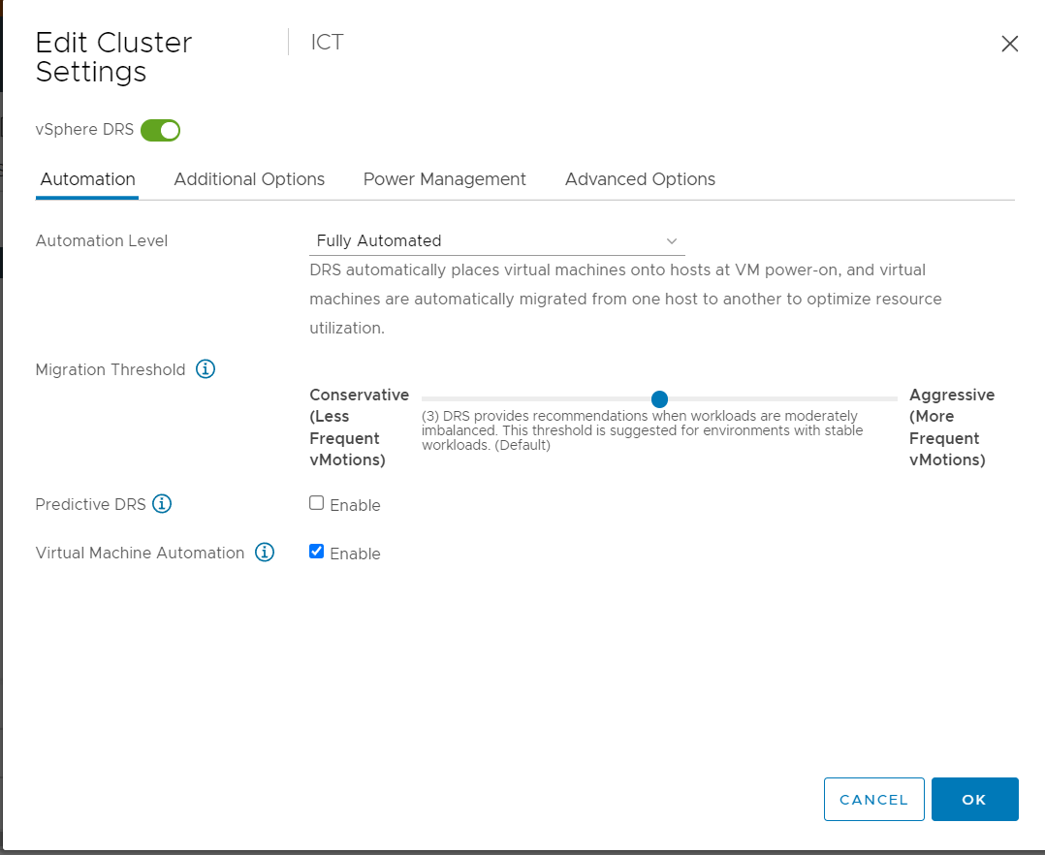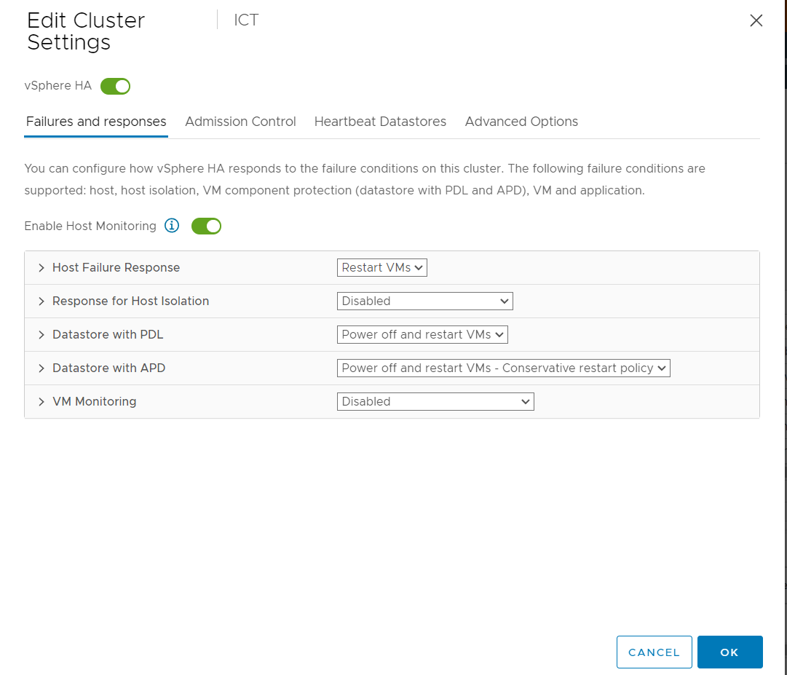

## High Avaliability ( HA )

## 

Here is the result of enabling HA on.

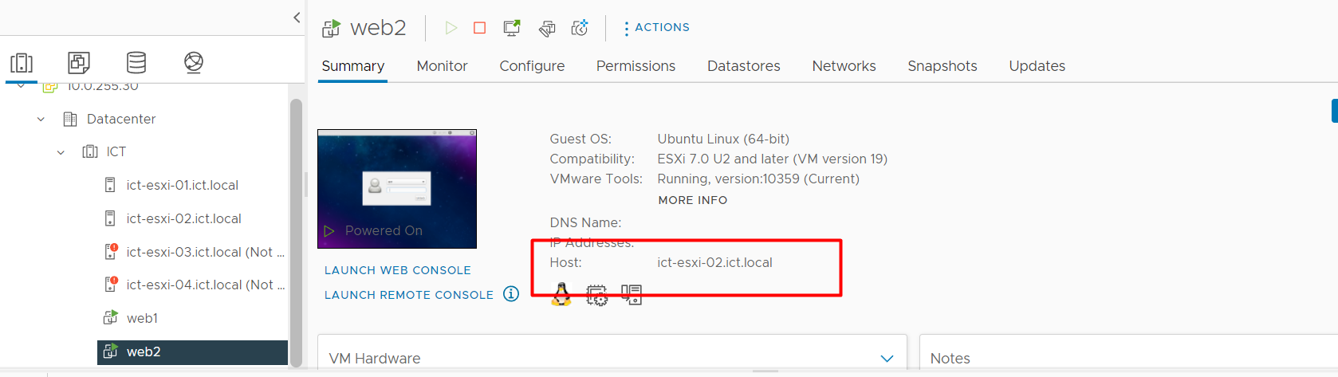

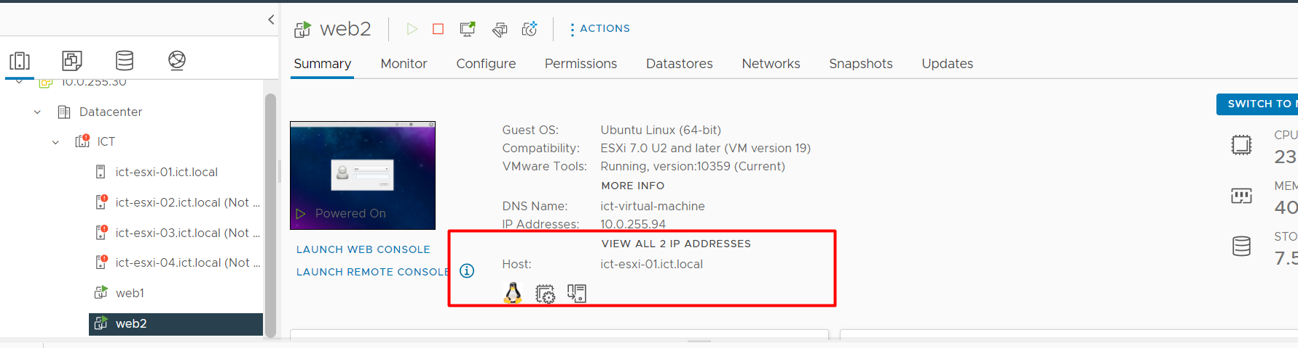

## Backup with Veritas

Due to HA, in case if one ESXI Server fails or shutdown, the VM deployed on them will be transferred to other ESXI host and will be active after a few minutes so that it can be used if there are websites or servers that need to run without down time.

For Data backup, Microsoft Window Server 2016 is deployed with IP address of 10.0.255.34 and Veritas CD file is added on that Server and new hard disk is added.

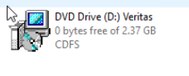

After that activate that new hard disk and initialize it for the purpose of building storage for veritas storage. After setting up step by step, we join it with VCenter so that if Vcenter is closed and can’t open back, there will be no lost data since we have veritas which can be backed up in regular schedule.

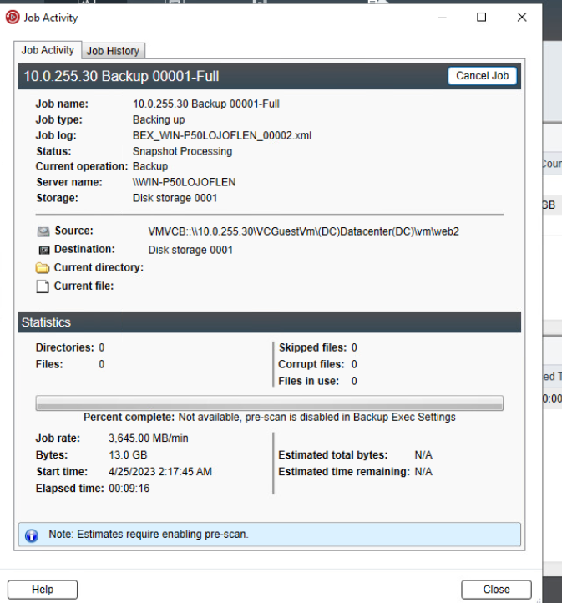

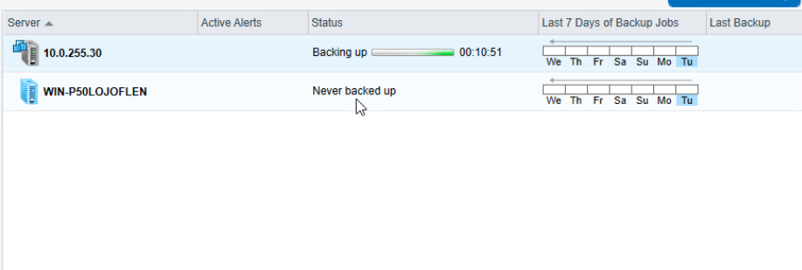

Restoring Data Backup

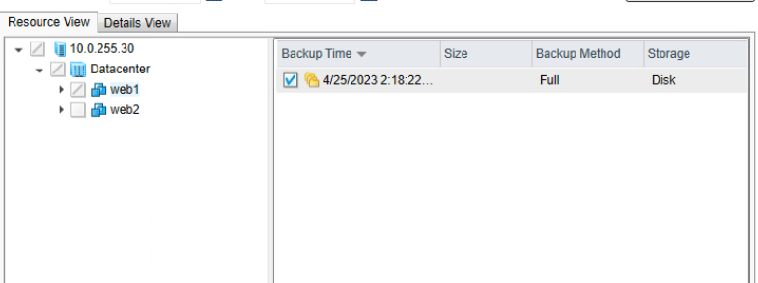

Choosing where to store back data

